## Spike - Task Management Systems:

When looking at various task management systems I first looked at some of the suggested platforms given towards the begging of class. From there I narrowed it down to Asana and Trello. I looked around each of the platforms web sites to get an idea of their functionality. Asana had a great deal of connectivity options, particularly with platforms like GitHub, and is very group focused and has some specific functionality that could be useful on a coding project. However, it looked like the potential learning curve to get going might be steep and include functionality I would not need on such a small project. While Trello lacked some coding specific features available with Asana in the free version, but it looked to be very easy to set up and get started. Based on the two-week timeline for completing Sprint 3 I’m leaning towards using Trello for its simpler learning curve and quick start up time.

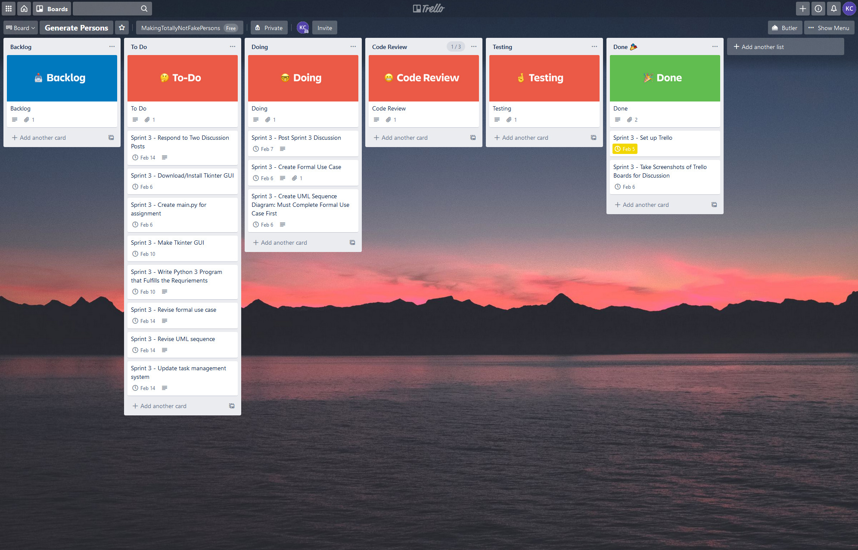

## Formal Use Case:

**Name**: Generate a given number of street addresses for a selected state

**Actor**: Researcher

**Flow**:

1. Open application.
2. Select a given state.
3. Select number of addresses to generate.
4. Select “Output to .CSV”.
5. Generate addresses.
   1. Must give results within 30 seconds.
6. Display generated addresses in GUI.
7. Output same generated addresses to .CSV file.
8. Application ends.

## UML Sequence Diagram:

